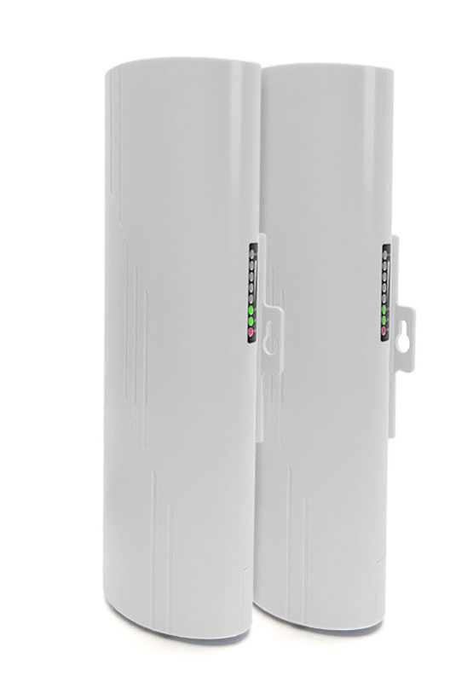
Product characteristics
- Digital display, one key pairing, automatic connection, no setting, convenient and fast, no need for mobile phone computer to complete;
- Support point-to-point, point-to-multipoint bridge, flexible application, to meet the needs of different application scenarios;
- 5.8G Frequency band, support spread spectrum, up to 300Mbps wireless transmission rate;
- Strong anti-interference ability, not affected by the external environment, stable transmission;
- Adopt Qualcomm engineering chip, stable and reliable performance;
- High-power circuit design, built-in high-gain directional antenna, strong signal strength, longer transmission distance;
- Support timing restart, reduce the system operation cache, optimize the system operation, so that the equipment can run for a long time without delay;
- Support to hide and bridge SSID wireless signal, to avoid wireless terminals to search the signal, to avoid malicious attacks on network transmission data, to ensure the security of user data;
- Support 24V PoE power supply and 12V DC power supply, plug and play, more flexible power access;
- Outdoor rainproof design, IP65 protection grade, rain, dust, wind, sun protection, easy to adapt to a variety of harsh outdoor environment, to ensure long-term stable operation of equipment;
- Olive design, simple and generous, simple and convenient installation, can be wall hanging, can hold the pole fixed installation;
- Suitable for major outdoor application scenarios, such as: outdoor site monitoring, tower crane monitoring, scenic spot monitoring, elevator monitoring, plant monitoring, dock monitoring, community monitoring, outdoor network transmission and other application scenarios.

Product Specifications
Product Name | 5.8GHigh Power Long Distance Digital Wireless Bridge
Product Model | BS500T
Hardware Specifications
Hardware System | Main chip | AR9344
Hardware System | Memory | 64MB
Hardware System | FLASH | 4MB
Wireless Parameters | Protocol standards | IEEE 802.11a/n
Wireless Parameters | Working band | 5.8G: 5180MHz ~ 5825MHz
Wireless Parameters | Wireless rate | 300Mbps
Wireless Parameters | Transmit power | 23dBm ± 2dBm
Physical Interface | Network interface | 2*10/100Mbps Ethernet ports (both support 24V PoE power supply)
Physical Interface | Hardware buttons | 1*digital button /RESET button
Physical Interface | Power port | 1*DC power port, supporting 12V DC power supply
Physical Interface | Pull the switch | 1*pull switch (free switch between end A and end B)
Physical Interface | Digital display | 1*digital display (support 0~9~A~F 16 channels display)
Wireless Type | Wireless type | Built-in 14dBi dual-polarized directional antenna
Indicator Light | LED indicator | POWER, WAN/LAN, WAN/LAN, WIFI , 4 lights
Power Supply/  Power Consumption | Mode of power supply | Support DC12V 1A power supply and 24V PoE power supply
Power Supply/  Power Consumption | Overall power | < 6 w
Product Accessories | Mainframe | 5.8GHigh power remote digital wireless bridge *1
Product Accessories | Power adapter | 24V 0.5A PoE power supply
Product Accessories | Other | User Manual *1, Warranty card *1, Certificate *1, stainless steel hoop *1
Appearance/Packaging | Exterior color | White
Appearance/Packaging | Product size | 250mm* 90mm*60mm(L*W*H)
Appearance/Packaging | Package size | 270mm*98mm* 100mm(L*W*H) (single pack)  295mm*283mm*82mm(L*W*H) (pair pack)
Appearance/Packaging | Weight | < 1kg(single pack)  < 2kg(pair pack)
Other | Optimal power distance for PoE cables | Within 65meters (Super Category 5 cable or above)
Other | Bridging distance | 0-4 km
Other | IPC drive capacity | 15 way, no stuck, no delay
Other | Installation method | Pole installation, wall mounted installation, bracket installation
Other | Level of protection | IP65, 2KV lightning protection
Software Specifications
System Operation Mode | Normal mode | This mode supports AP mode, client mode, and trunk mode  Support manual pairing bridge (when entering this mode, nixie mode fails)
System Operation Mode | Nixie tube mode | Automatic pairing, support digital one-click pairing, no need to enter the WEB interface manual pairing
Bridge Networking Mode | Digital pairing | Supported, digital display, one-click pairing, convenient/ easy / quick
Bridge Networking Mode | Manual pairing | Support
Bridge Networking Mode | Point-to-point bridging | Support
Bridge Networking Mode | Point-to-multipoint bridging | Support
Networking | Work mode | Wireless Bridge, AP mode, client mode, Relay mode
Networking | LAN Setup | Support
Networking | DHCP Server | Support
Networking | Wireless network status display | Support
Wireless Settings | SSID modification | Support
Wireless Settings | SSID Hiding | Support
Wireless Settings | Encryption method | WPA-PSK, WPA2-PSK
Wireless Settings | Bandwidth Settings | Support
Wireless Settings | Wireless channel modification | Supported, spread spectrum available
Wireless Settings | Wireless subscriber isolation | Support
Wireless Settings | Wireless power regulation | Support
Wireless Settings | Multiple SSIDs | Support
System Management | Web interface Management | Support
System Management | System language | Chinese/English supported
System Management | Dongles | Support
System Management | Timed restart | Support
System Management | User Management | Support
System Management | Firmware upgrades | Support
System Management | Firmware file import and export | Support

Interface description
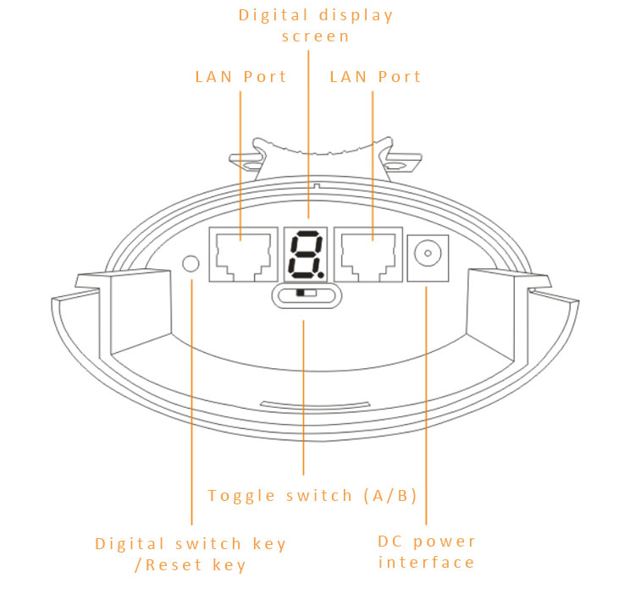

Product size
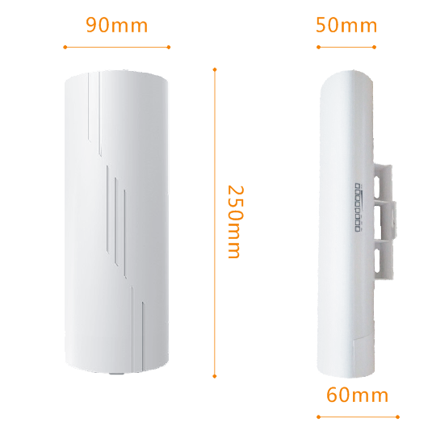

Product Application
- Wireless monitoring transmission point-to-point application 1

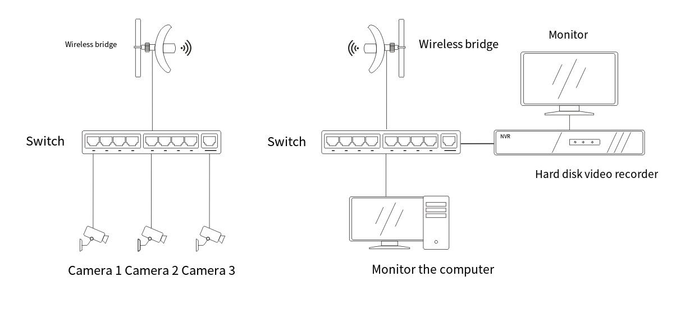

- Wireless monitoring transmission point-to-point application 2

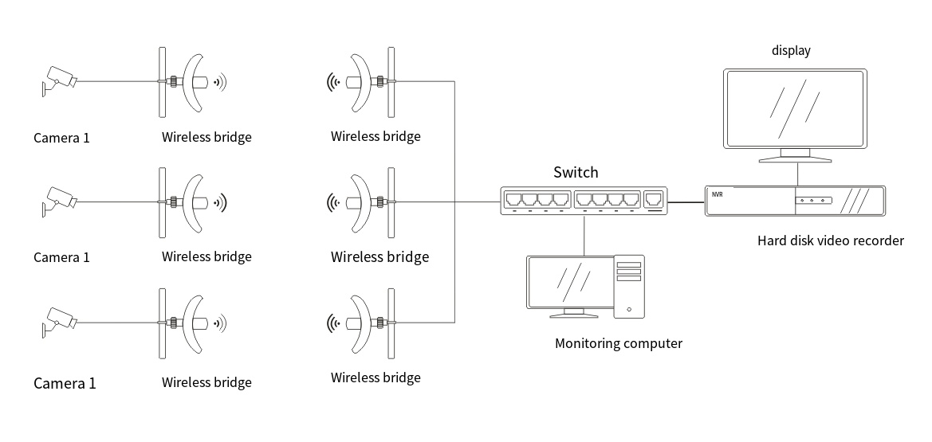

- Wireless monitoring transmission point-to-multipoint application

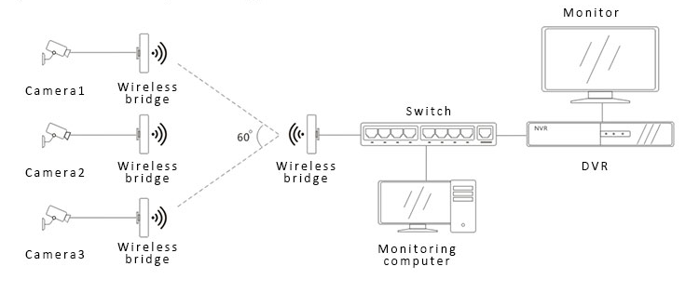

- Internet of Things data transmission application

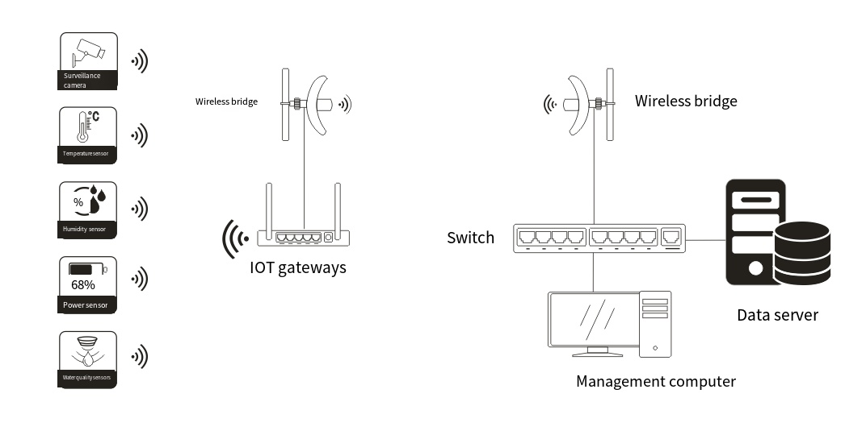

5. Internet wireless transmission application 1

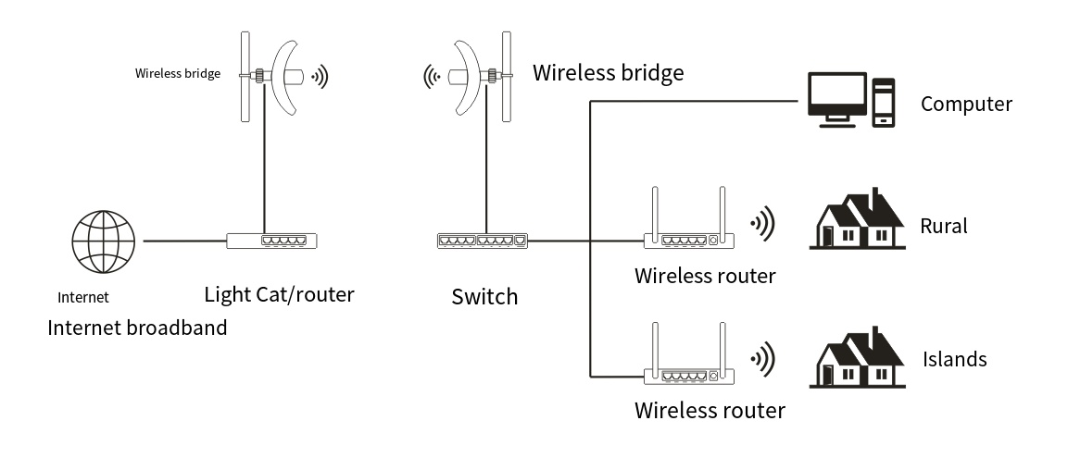

6. Internet wireless transmission application 2
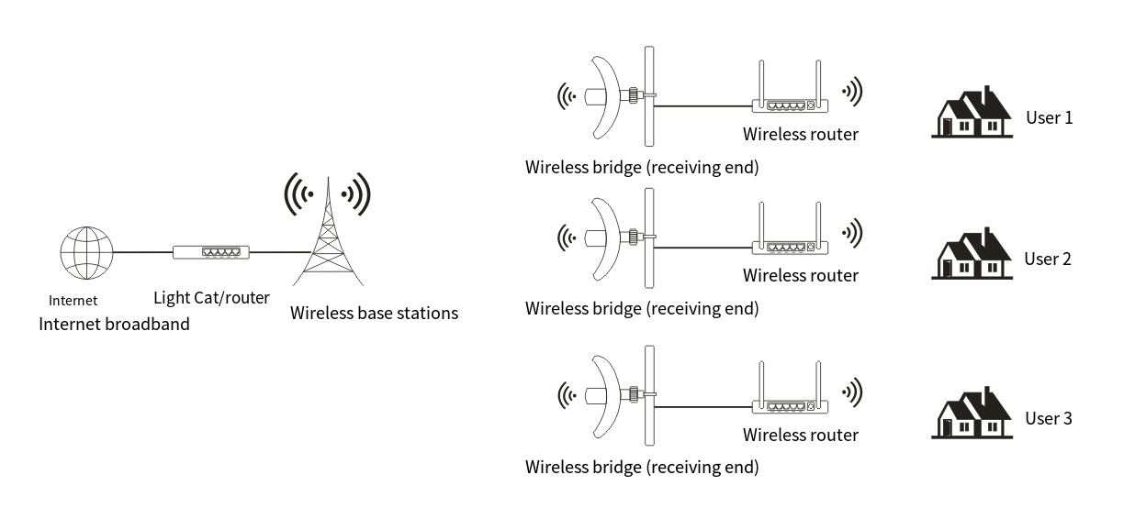

7. Internet coverage application 3

